**AdvMaths & MapProjs Lab1**

Yu-Hao Chiang 3443130

**Exercise 1 – Vectors in Space**



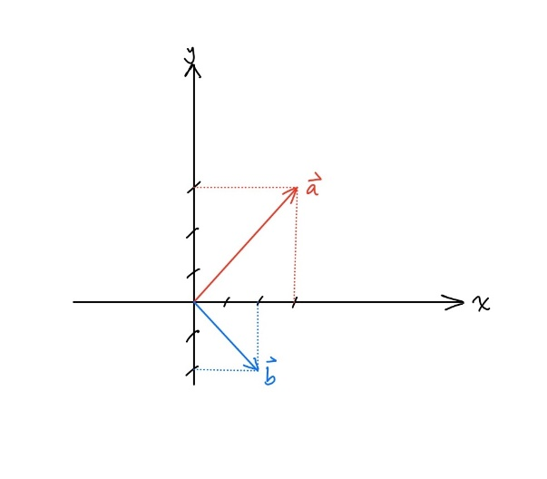

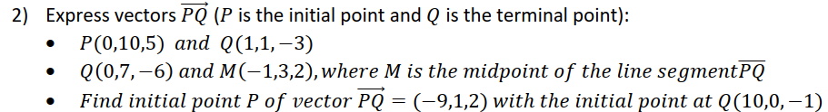

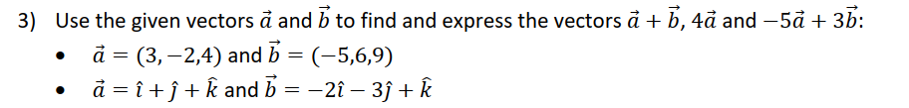

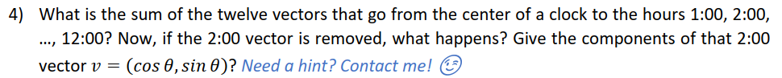

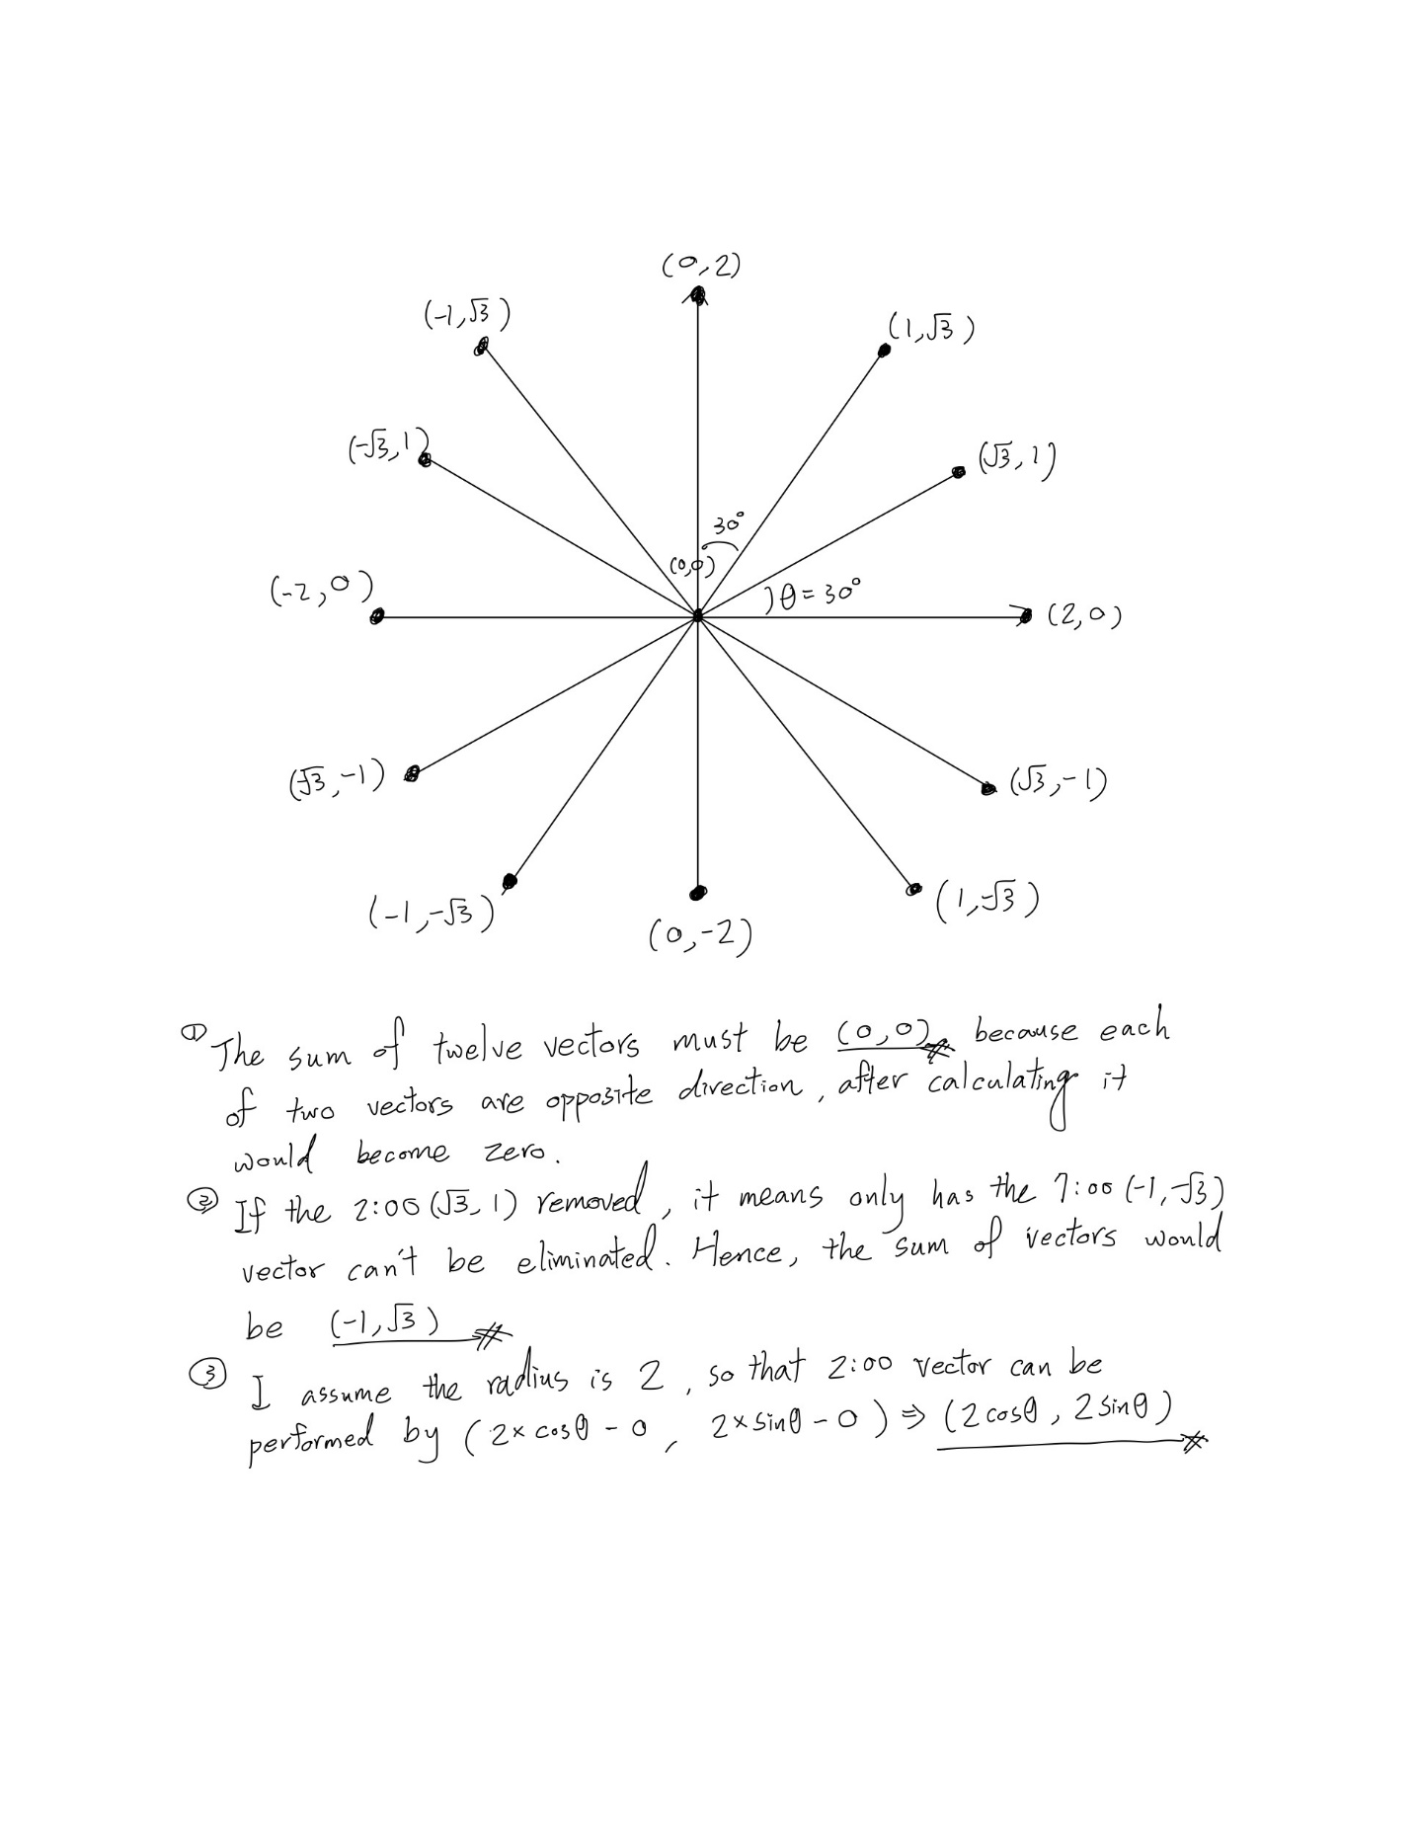

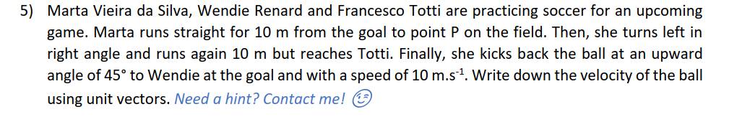

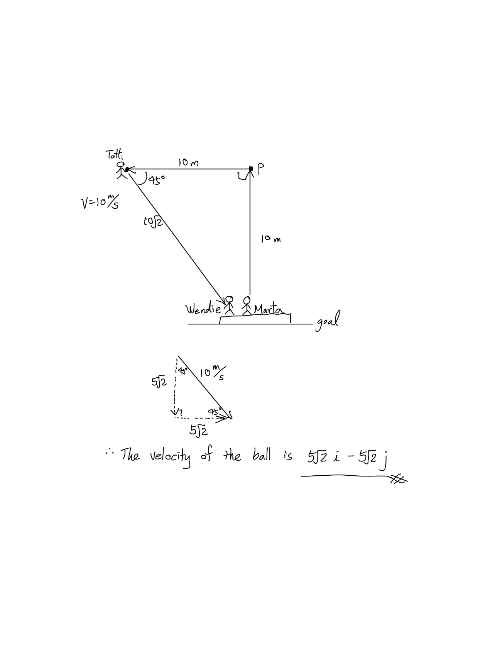

**Exercise 2 – The Dot Product**

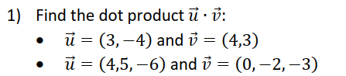

$\vec{u}∙\vec{v}=12-12=0$

$\vec{u}∙\vec{v}=0-10+18=8$

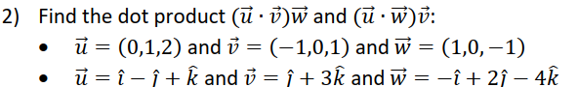

$\left(\vec{u}∙\vec{v}\right)\vec{w}=2\left(1,0,-1\right)=(2,0,-2)$

$$\left(\vec{u}∙\vec{w}\right)\vec{v}=-2\left(-1,0,1\right)=(2,0,-2)$$

$\left(\vec{u}∙\vec{v}\right)\vec{w}=2\left(-\hat{i}+2\hat{j}-4\hat{k}\right)= -2\hat{i}+4\hat{j}-8\hat{k}$

$$\left(\vec{u}∙\vec{w}\right)\vec{v}= -7\left(\hat{j}+3\hat{k}\right)= -7\hat{j}-21\hat{k}$$

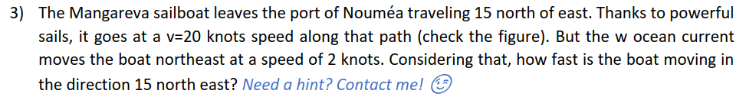

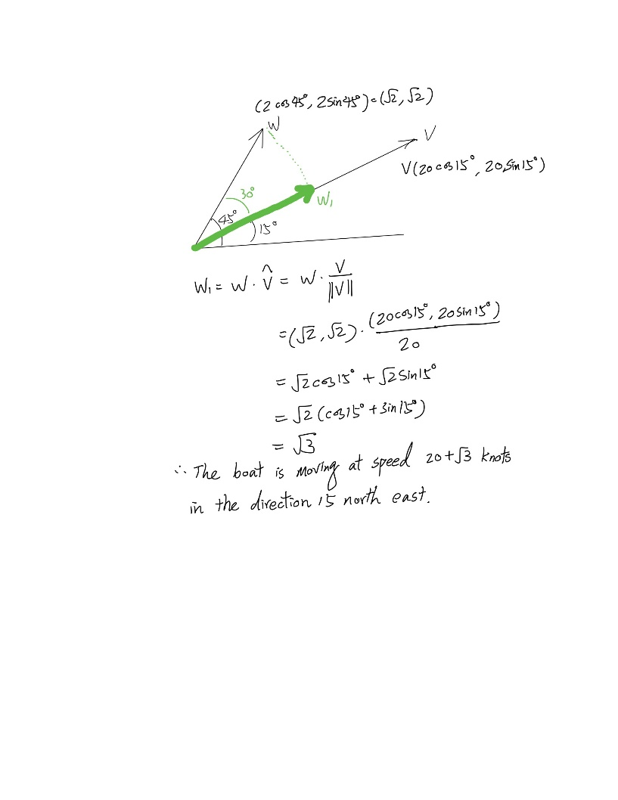

**Exercise 3 – The Cross Product**

